Consultation Form

Surname: ………………………………………………………………………………Title: …………………………………………
First Name: …………………………………………………………………….. DoB: ………………………………………..
Address: ………………………………………………………………..…………………………………………………………………
…………………………………………………………………………………………Postcode: ………………………………………
Contact Phone No: …………………………………………………
Email: ……………………………………………………………………………………………………………………………………….
Name & Address of GP: ……………………………………………………………………………………………………………
How did you hear about us Recommendation/Web/Other……………………………………………………..
Medical History
Do you suffer or ever suffered of any of the following?
Thyroid problems | Yes | No |  | Stroke | Yes | No
Heart conditions | Yes | No |  | Thrombosis/phlebitis | Yes | No
Rheumatoid arthritis | Yes | No |  | Cancer | Yes | No
Epilepsy | Yes | No |  | Recent surgery | Yes | No
Asthma or other respiratory conditions | Yes | No |  | Digestive problems | Yes | No
Diabetes | Yes | No |  | Headaches | Yes | No
Steroid use | Yes | No |  | Allergy | Yes | No
Blood pressure issues | Yes | No |  | Anxiety | Yes | No
Skin infections/conditions | Yes | No |  | Depression | Yes | No

Are you experiencing menopause?.....................................................................................................
Are you pregnant? If so, how many weeks……………………………………………………………………………………….
Please give details of any of the above including regular medication you are taking.
……………………………………………………………………………………………………………………………………………………….
Is there anything else about your health and wellbeing you would like to tell us?
………………………………………………………………….………………………………………………………………….…………………
………………………………………………………………….………………………………………………………………….…………………
………………………………………………………………….………………………………………………………………….…………………
Current Problem
Please circle the site of pain and if more than one please number them in priority order

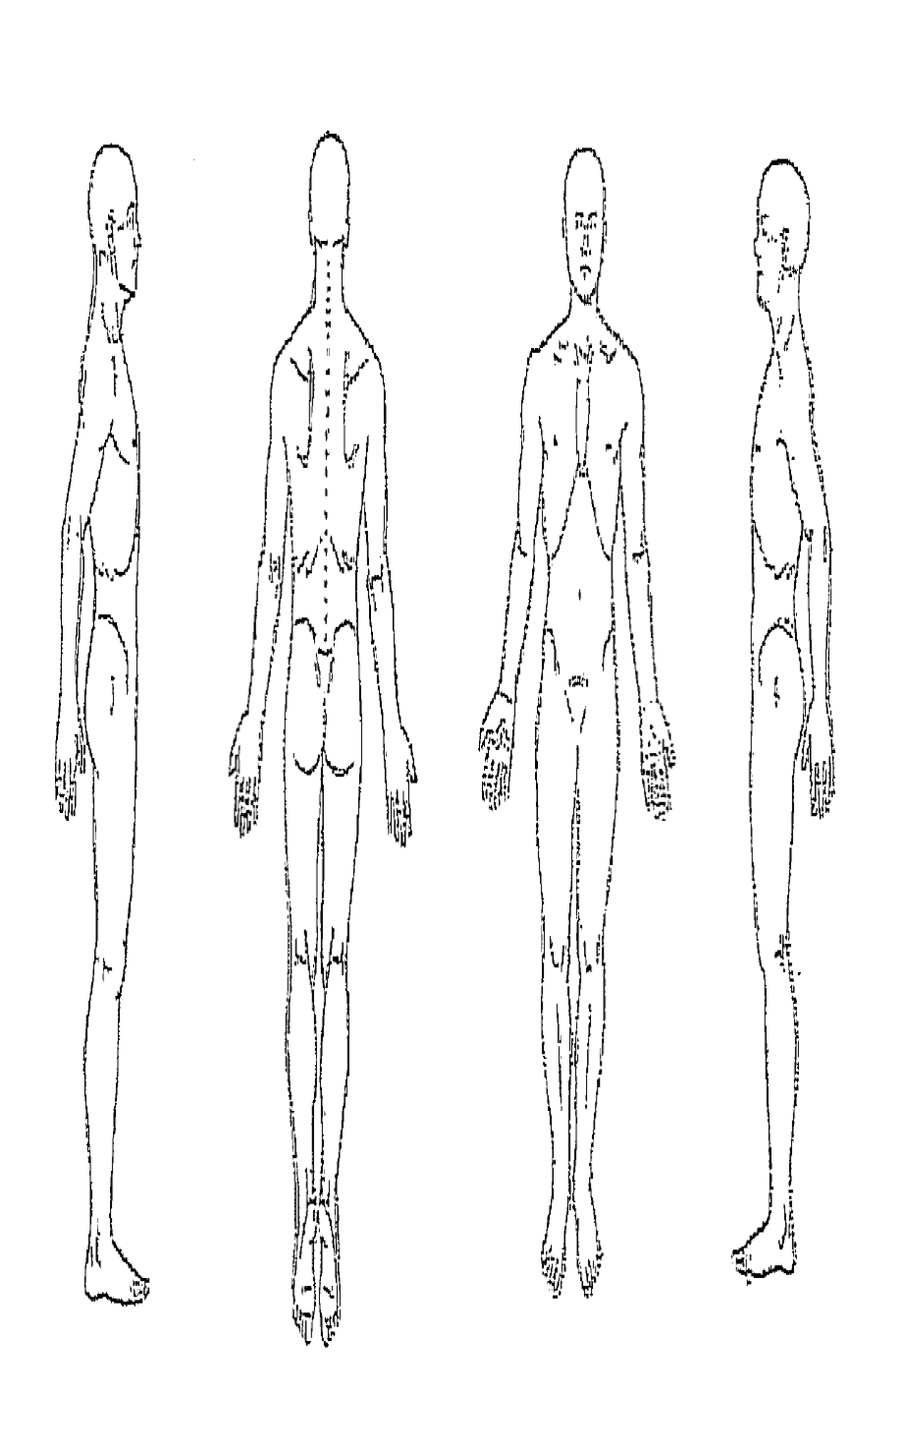
Where are you at the moment in the pain scale below?
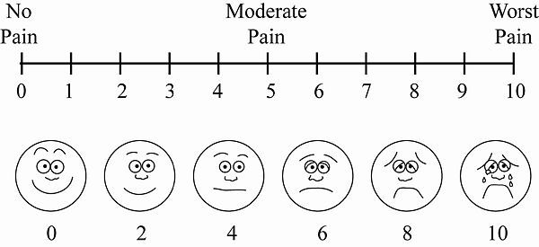
Describe in your own words what you are feeling and how it’s affecting your daily life.
………………………………………………………………….………………………………………………………………….…………………
………………………………………………………………….………………………………………………………………….…………………
………………………………………………………………….………………………………………………………………….…………………
………………………………………………………………….………………………………………………………………….…………………
………………………………………………………………….………………………………………………………………….…………………

When did it start?…………………………………………………………………………………………………………………………………………….
How did it start/happened?...................................................................................................................................
…………………………………………………………………………………………………………………………………………………………………………
What makes it worse? ……………………………………………………………………………………………………..
…………………………………………………………………………………………………………………………………….
What makes it better? ………………………………………………………………………………………………………………………
…………………………………………………………………………………………………………………………………………………………..
Lifestyle Questions
These questions help us to understand the close rapport between your lifestyle and the current issue

What physical activity / sports do you do during the week? And how often?.......................................
…………………………………………………………………………………………………………………………………………………………..
What’s your mood been recently?
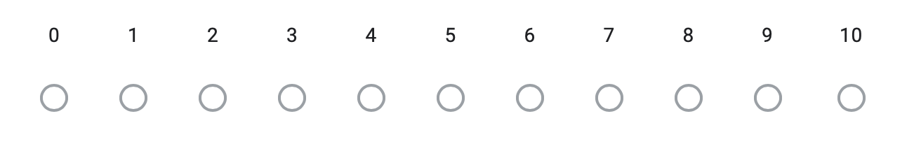
What’s your general feeling of stress recently?
What's your favourite activity to help you wind down and relax?
………………………………………………………………….………………………………………………………………….…………………
………………………………………………………………….………………………………………………………………….…………………
………………………………………………………………….………………………………………………………………….…………………
How do you rate your quality of sleep?
Good
Poor
Fair poor
How many hours do you usually get?..........................................

Hobbies, what do you like to do? ……………….………………………………………………………………….……………
………………………………………………………………….………………………………………………………………….…………………
………………………………………………………………….………………………………………………………………….…………………
What brings you to see me, what are your reasons for treatment, what results do you expect?
………………………………………………………………….………………………………………………………………….…………………
………………………………………………………………….………………………………………………………………….…………………
………………………………………………………………….………………………………………………………………….…………………
Declaration and Informed Consent

The information I have given in this form is honest, accurate and correct to the best of my knowledge. I have been given the opportunity to ask all the questions about its content, and all of my questions have been answered to my satisfaction. I appreciate that although all reasonable steps to reduce risk of infections have been taken, including screening potential COVID-19 cases and undertaking increased hygiene and distancing protocols there may still be a risk of infection from face to face appointment. I knowingly and willing consent for Face to Face appointment to take place.

Client Signature: ………………………………………………. Date : ………………..……………………………………..

Data Protection Policy

"Pulse Therapy fully complies with the most up to date Data Protection Policy and has a transparent approach to Data Processing which empowers individuals to know about the collection and use of their personal data. We collect data for ensuring we have the right information for assessing your suitability to treatment, for completing the appropriate treatment, for contacting you regarding appointment follow-ups and for a referral to GP or other healthcare practitioners if deemed necessary. Your data may be viewed by clinic staff to ensure continuity of care is given and for standards clinic running purposes. In addition, the data may also be shared with NHS Trace and Test if required to minimise the spread of Covid-19. We collect only data that is relevant to those purposes, and we keep it for 7 years. All information held will be treated as strictly confidential and will only be released to any other external party with the consent of the client."
I have read Pulse Therapy’s Data Protection Policy and consent to Pulse Therapy processing records as outlined above and understand that I can withdraw my consent on the processing of data at any time.

Client Signature: ………………………………………………. Date : ………………..……………………………………..

Treatment consent

You will complete this AT THE TIME OF YOUR APPOINTMENT

The information I have given in this form is correct to the best of my knowledge I have been explained the effects, benefits and risks associated with treatment including COVID-19 risk of infection. I have had the opportunity to ask all the questions about the process, and all of my questions have been answered to my satisfaction. I consent for treatment to take place and understand that I can withdraw my consent at any time.

Client Signature: ………………………………………………. Date : ………………..……………………………………..

